DOI: https://doi.org/10.XXXX/jmsxxxxx UDC: xxxxxxxxxxx
Type of the paper

Title of the Paper,
Please Use Soft Line Break
(Shift+Enter) for Long Titles if Needed
Author 1, Author 2, Author 3 (Please, type full names of all authors. Do not use just initials for their names)
Abstract: Abstract should contain short presentation of the paper and results given (maximum 200 words).
Keywords: Keywords, With initial caps (maximum six keywords).
1. Heading 1, Should be in Accordance with the
Capitalization Rules
After keywords, the first section is usually Introduction, although some other headings can be used. The maximum length of the paper shall not exceed 3000 words both for Original scientific paper and Invited paper, 4500 words for Review paper, 1000 words for Editorial, and 1500 words for Short report, respectively (excluding title, abstract, tables/figures, figure legends, Acknowledgements, and References).
2. Heading 2
Each new paragraph should be clearly indicated. If the style used does not provide visual identification of paragraphs, author(s) should insert one blank line between paragraphs.
2.1. Subheading should be in sentence case (thus, lowercase
except for the first letter, names and acronyms)
For equations insert TAB before and after equation including the number. Equations use 11pt for full size. The best is to use trial version of MathType, since it can re-format all equations to change the full size and styles. Please, DO NOT type equations as text (especially, do not use subscript and superscript option in the text to simulate equations, e.g. x₁, x₂, ..., x_{n}), neither display ones (centered in a separate line) nor inline ones.
Here are some examples of display equation:
$$h_{o}-h_{f}=μ^{2}R$$ | (1)

$$\sum_{k=0}^{n-1}{\left(a+kd\right)=\frac{n}{2}\left(2a+\left(n-1\right)d\right)}$$ | (2)

where after-equation text has no first-line indent, unless it is intended to be a new paragraph. Also, if using MathType, please do not use user-defined styles, unless unavoidable. Please, do not style any symbols or other content as user-defined, but choose built-in styles (e.g. vector, variable, text, etc.), since everything concerned with style and size of each equation element will be done simply by applying our journal style to all equations. Thus, doing any manual formatting will be superfluous and can cause additional problems. Please, always put some text before equations. A new paragraph or a sentence cannot start with a centered equation.
3. Figures
Kindly export figures from programs used for simulations or measurements in high quality format, preferably in vector (e.g., EPS) format. Also, export figures drawn in Corel Draw, Visio, etc. in EPS format, and save the original file to send it with the paper. You can send us exported EPS files and/or original files, so we can make minor corrections fast, if necessary, thus your paper, if accepted, will be published sooner. For photos and similar content please use highest quality JPEG or TIFF, while for diagrams high-resolution PNG format is preferable, if vector format is not available.
Please Avoid Drawing Figures in Microsoft Word directly, especially combining elements in Word with scanned images (e.g., inserting scanned graphs and putting labels in Words as text boxes)!
3.1. Why not making figures directly in MS Word?
The main reason for this is that JMS, in addition to the printed version, publish the online version in PDF format, so important details can be seen in figures when zoomed-in. If figures are low resolution bitmaps or vectors made in MS Word, readers might not see correctly the results presented in the paper (especially since drawing tools in MS Word are not meant for high-precision drawing).
Thus, in addition to the quality of the results obtained, papers considered for publication must meet the technical requirements as per this template. In short, besides the quality of result(s), paper considered for publication must meet technical quality to be published in JMS.
It is recommended that all figures are referenced somewhere in the text, e.g. Fig. 1 or Figs. 1 and 2. It is necessary to prepare figures in such a way that the all contents can be properly identified both in color and monochrome (graphs of different variables should be given in different styles, e.g. dotted, dashed etc.). The printed version will be in monochrome, while the online version will be in color.
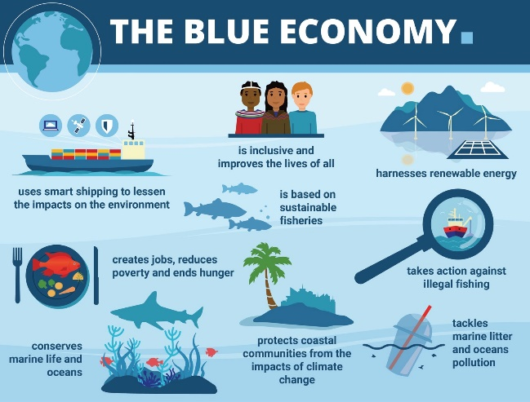
Fig. 1 – Description of the figure - Cambria 10p.
Fig. 2 – Figures should be inserted as vectors
whenever possible, preferably as EPS files.
4. Lists
Author(s) should use built-in styles for numbering (JText-numberedList)
- List element 1,
- List element 2, and
- List element 3,
and unordered lists (JText-unorderedList)
- List element 1,
- List element 2, and
- List element 3.
5. Tables
Tables should be referenced in text in bold font, e.g., as it is presented in Table 1. If the table cannot fit at the bottom of the page, please move it to the next page. Also, put units in square bracket, e.g. for seconds [s].
Table 1 – Description of the table - Cambria 10p.
 | IDCM |  | CONVENTIONAL
 | One level of  Decomposition [dB] |  | Three level of  Decomposition [dB]
Thr (%) | SNR | CR | SNR | CR
5 | 46.46 | 13.5 | 42.81 | 8.08
10 | 49.51 | 19.34 | 39.21 | 8.63
6. Conclusion
It is very important to write the paper in proper English, free of spelling or grammar mistakes. For that purpose, send your paper to professional lecturer. We can recommend you professional lecturers from Proof-Reading-Service (http://www.proof-reading-service.com).
All references should be formatted using examples given in the last section. References should contain correct data: the names of all the authors, paper title, publication name, date of publication, paper pages, and similar. Authors are expected to cite more recent references in the subject area. This will contribute to the higher quality of the paper.
7. Acknowledgments
In case Author(s) would like to mention the information on the support provided by a project or institution, it should be done here. For instance, this research is supported by Ministry of Science and Technology…
References
The template will number citations consecutively within the square brackets followed by a full stop. For in-text reference, simply refer to the reference number (e.g., as in [3])—do not use “Ref. [3]” or “reference [3]” except at the beginning of a sentence: “Reference [3] was the first ...”
Always give all the names of the authors, do not use et al., even if there are six or more authors. Papers that have not been published, even if they have been submitted for publication, should be cited as “unpublished” [4]. Papers that have been accepted for publication should be cited as “in press” [5]. Capitalize only the first word in a paper title, except for proper nouns and element symbols.
Number footnotes separately in superscripts. Place the actual footnote at the bottom of the page in which it was cited. Do not put footnotes in the abstract or reference list. Use letters for table footnotes.
For papers published in translation journals, please give the English citation first, followed by the original foreign-language citation [6].

[1] G. Eason, B. Noble, and I. N. Sneddon, “On certain integrals of Lipschitz-Hankel type involving products of Bessel functions,” Phil. Trans. Roy. Soc. London, vol. A247, pp. 529–551, April 1955. (references)
[2] J. Clerk Maxwell, A Treatise on Electricity and Magnetism, 3rd ed., vol. 2. Oxford: Clarendon, 1892, pp. 68–73.
[3] I. S. Jacobs and C. P. Bean, “Fine particles, thin films and exchange anisotropy,” in Magnetism, vol. III, G. T. Rado and H. Suhl, Eds. New York: Academic, 1963, pp. 271–350.
[4] K. Elissa, “Title of paper if known,” unpublished.
[5] R. Nicole, “Title of paper with only first word capitalized,” J. Name Stand. Abbrev., in press.
[6] Y. Yorozu, M. Hirano, K. Oka, and Y. Tagawa, “Electron spectroscopy studies on magneto-optical media and plastic substrate interface,” IEEE Transl. J. Magn. Japan, vol. 2, pp. 740–741, August 1987 [Digests 9th Annual Conf. Magnetics Japan, p. 301, 1982].
[7] M. Young, The Technical Writer’s Handbook. Mill Valley, CA: University Science, 1989.

Submitted: | DD/MM/YYYY | Author 1, Name of the first author  Affiliation,  Full Address,  Email: emailauthor1@format.com
Accepted: | DD/MM/YYYY
Author 2, Name of the second author
Affiliation,
Full Address,
Email: emailauthor2@format.com
Author 3, Name of the third author
Affiliation,
Full Address,
Email: emailauthor3@format.com

An earlier version of this paper was presented at the xxxxxxx – acronym of the conference/symposia, Town, Country.

